# 4.1-Test Techniques Overview

Chapter 4 part 1 EP _ BVA - start at 1:11

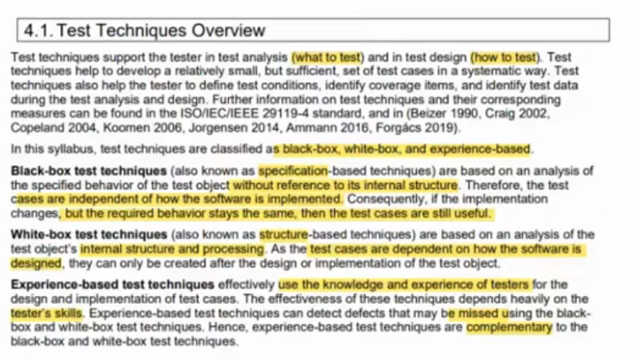

# 4.2-Black-Box Test Techniques

Chapter 4 part 1 EP _ BVA - start at 4:09

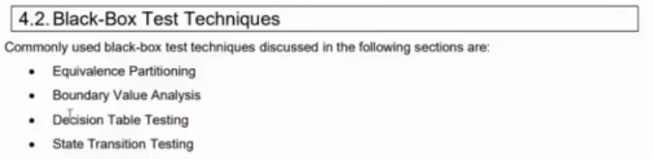

## 4.2.1-Equivalence Partitioning

### Slide

Chapter 4 part 1 EP _ BVA - start at 7:53

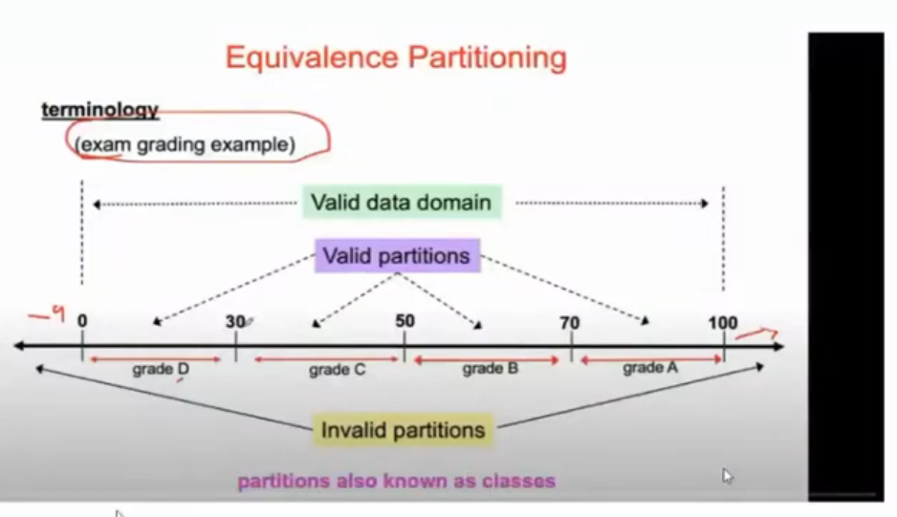

### Details

Chapter 4 part 1 EP _ BVA - start at 13:05

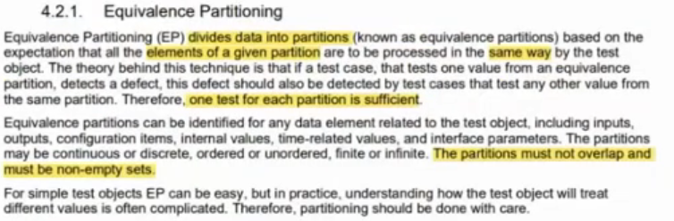

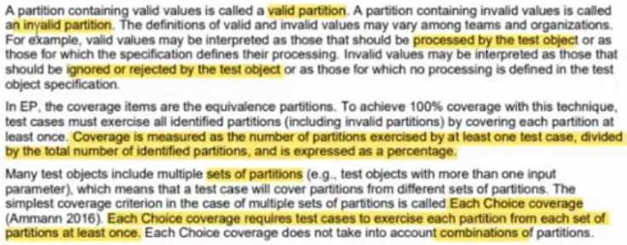

### Questions

Chapter 4 part 1 EP _ BVA - start at 19:38

Q1

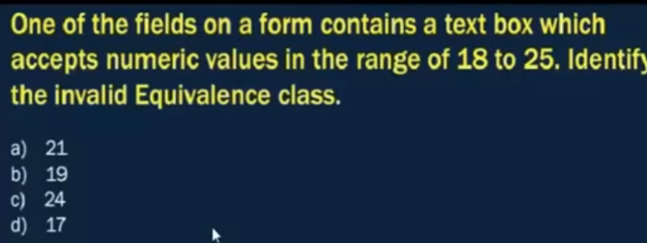

Q1 - Answer

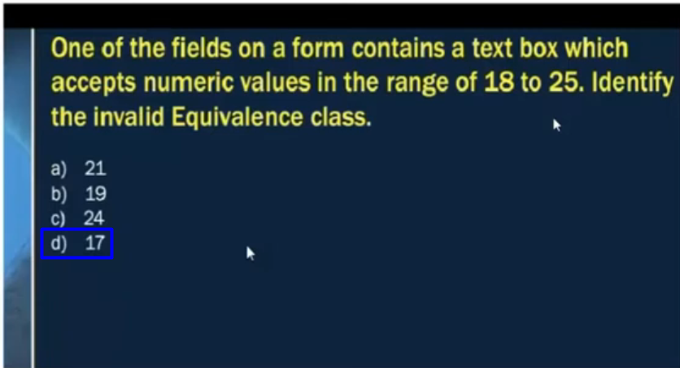

Q2

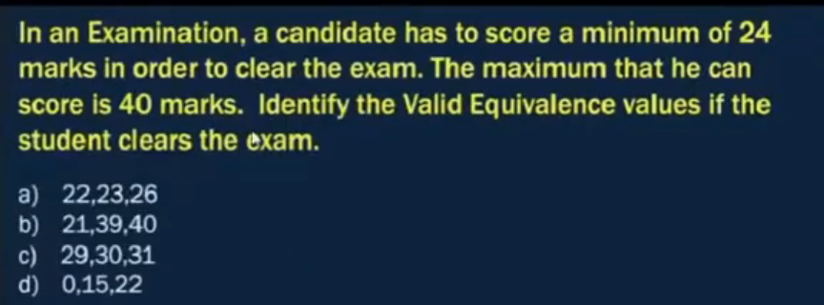

Q2 – Answer

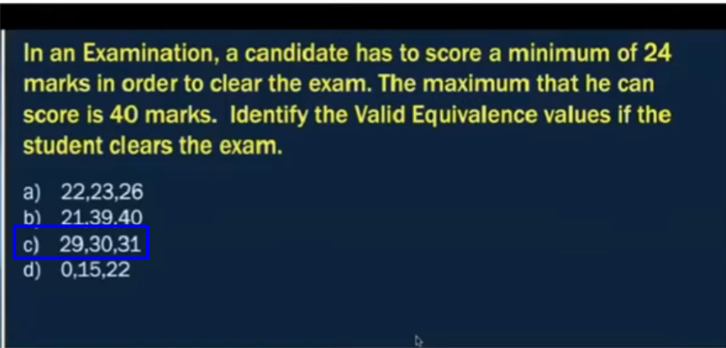

Q3

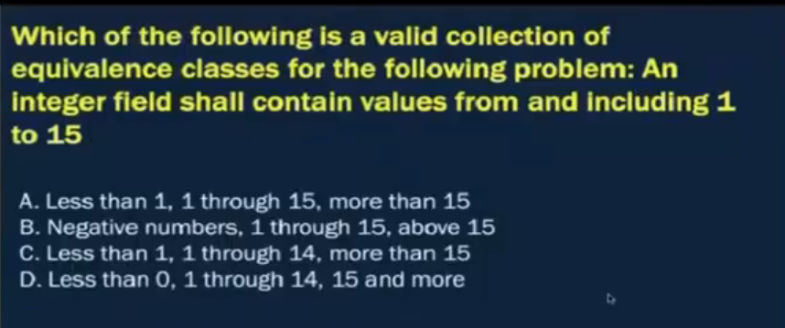

Q3 – Answer

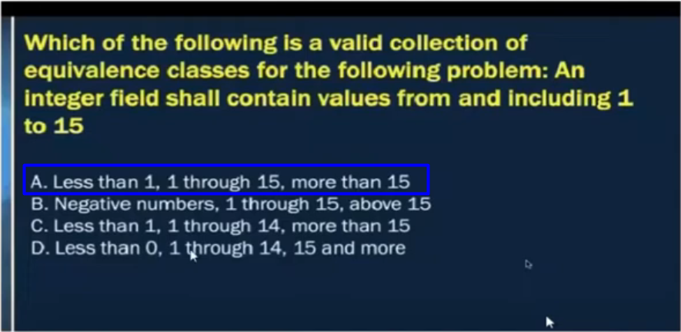

Q4

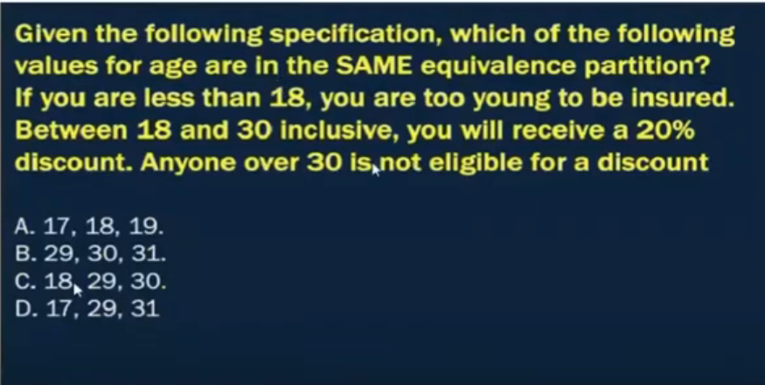

Q4 – Answer

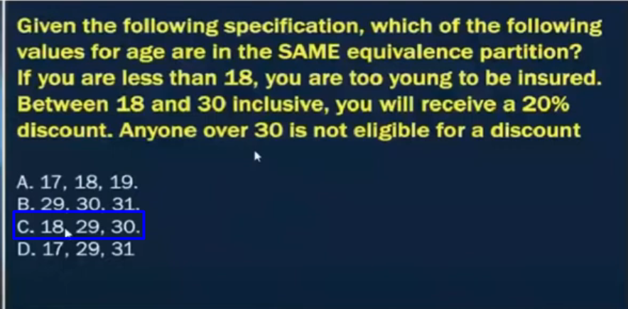

Q5

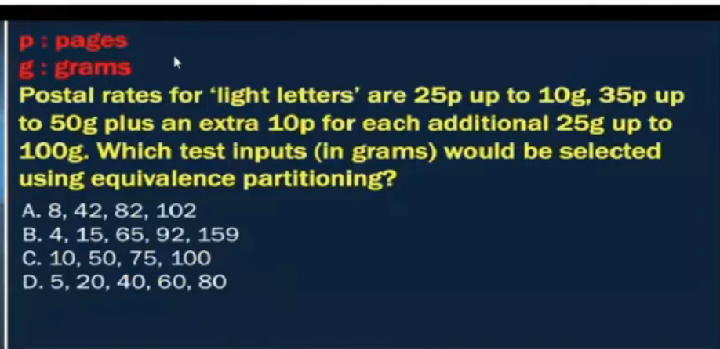

**# Source**: **Chatgpt (GPT-5-Standard) at [8/15/2025]**

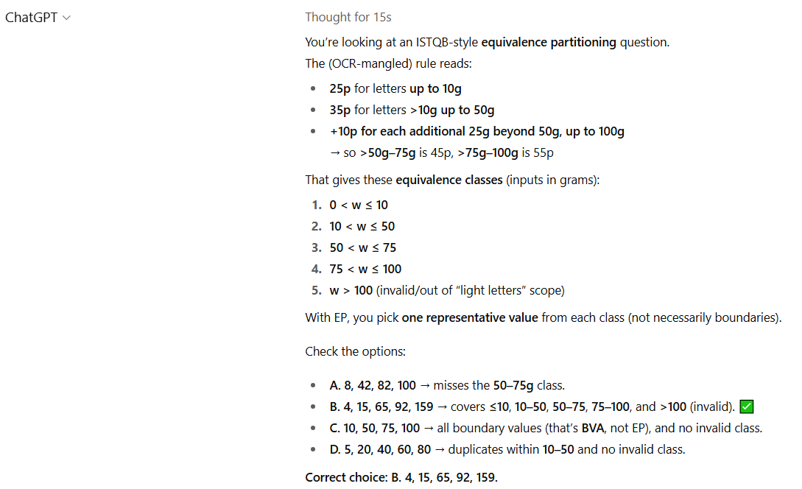

Q5 – Answer

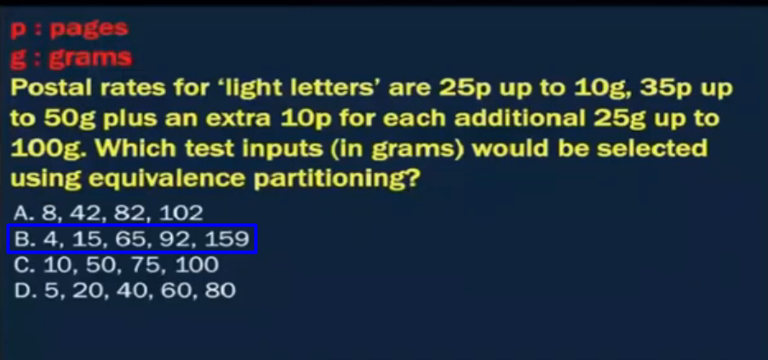

Q6

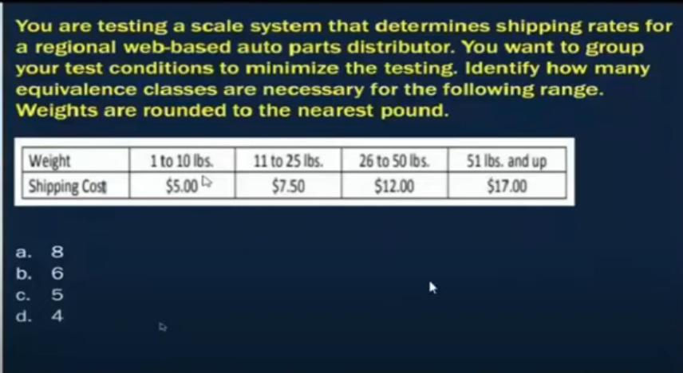

**# Source**: **Chatgpt (GPT-5-Standard) at [8/15/2025]**

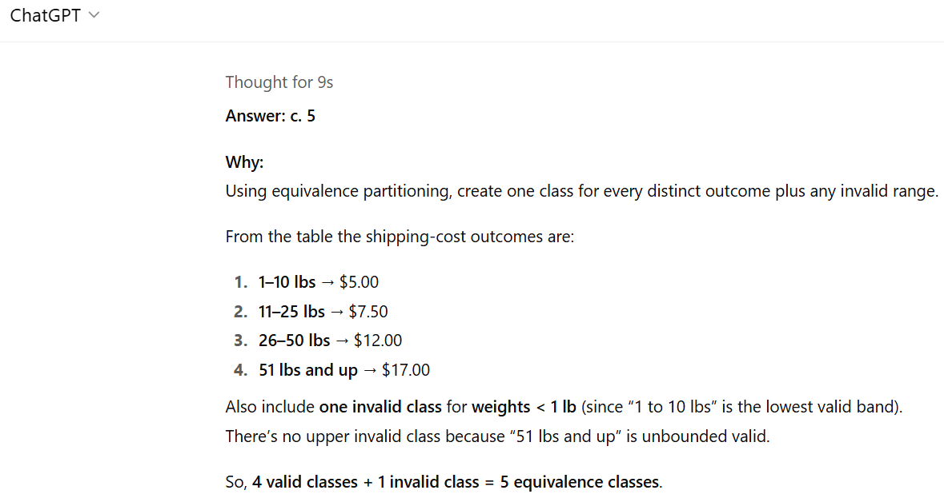

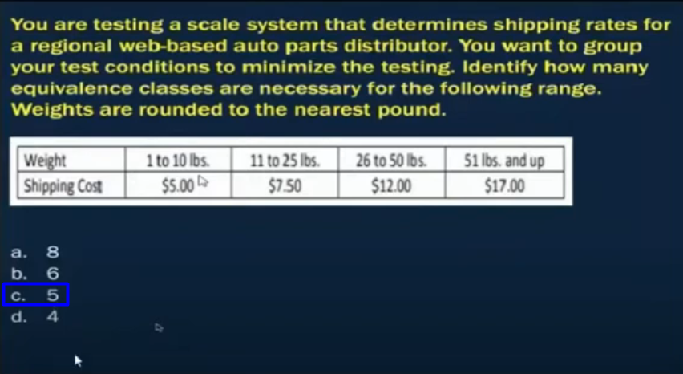

## 4.2.2-Boundary Value Analysis

### Slide

Chapter 4 part 1 EP _ BVA - start at 44:49

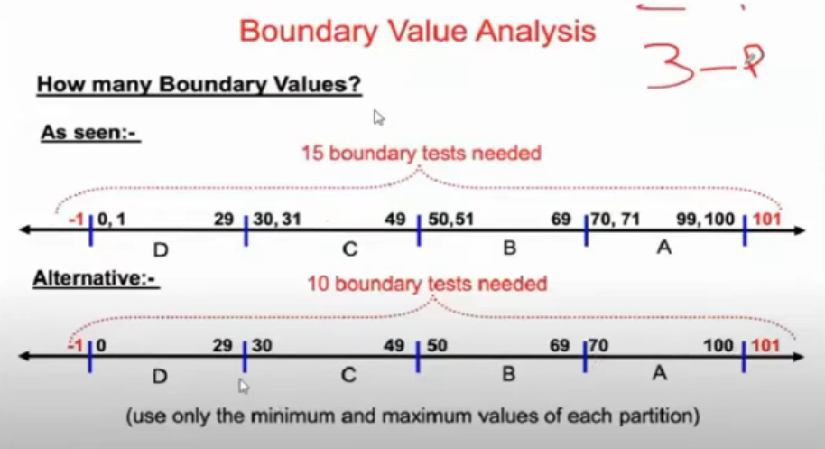

### Details

Chapter 4 part 1 EP _ BVA - start at 50:43

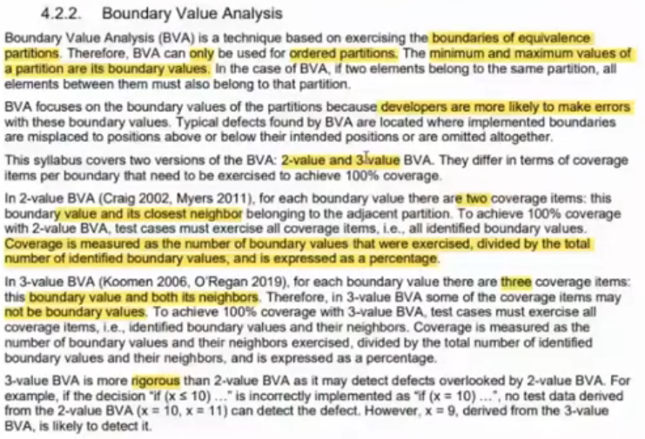

### Questions

Chapter 4 part 1 EP _ BVA - start at 50:53

Q1

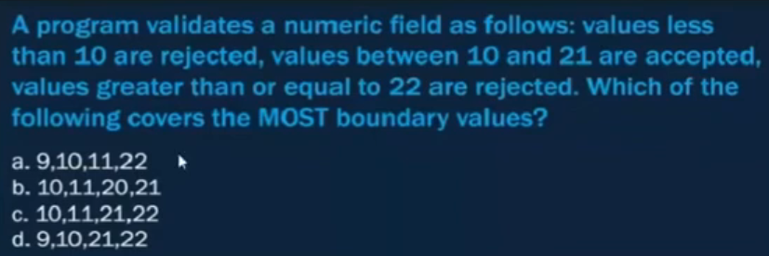

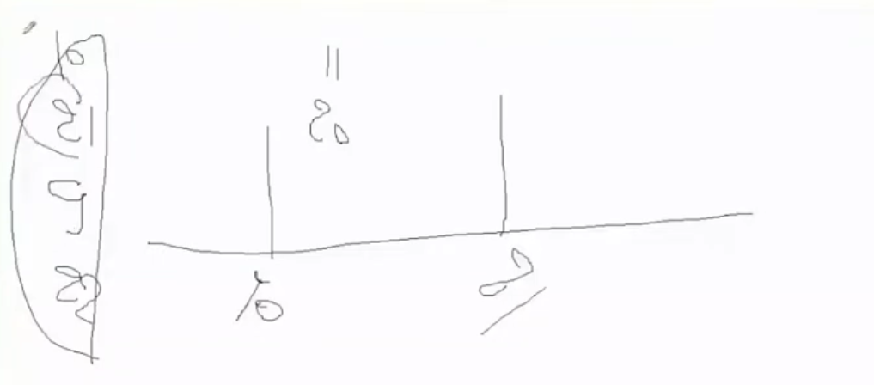

Q1 - Answer

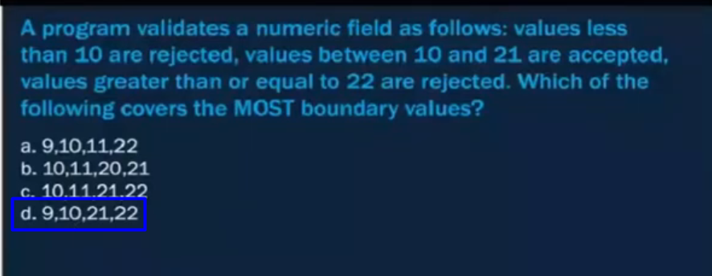

Q2

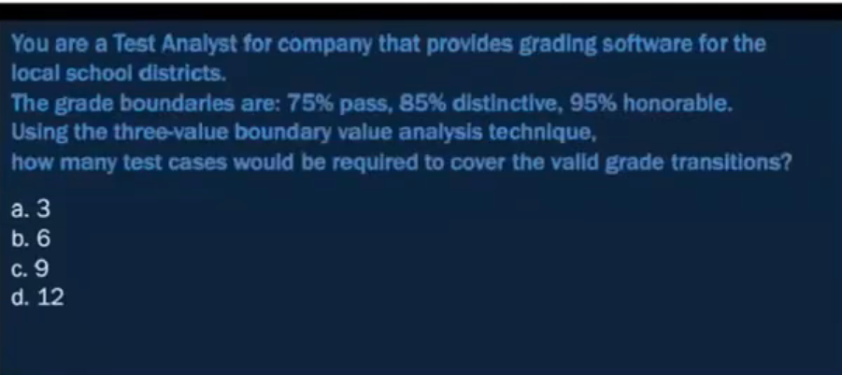

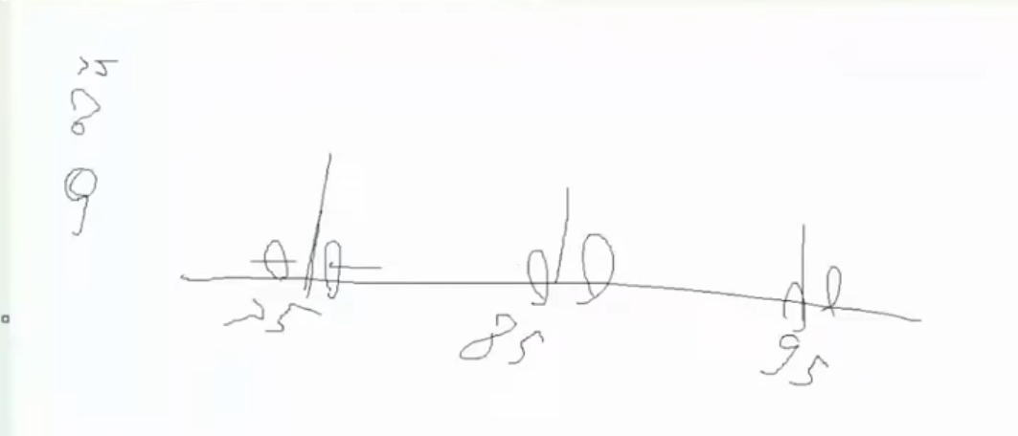

Q2 - Answer

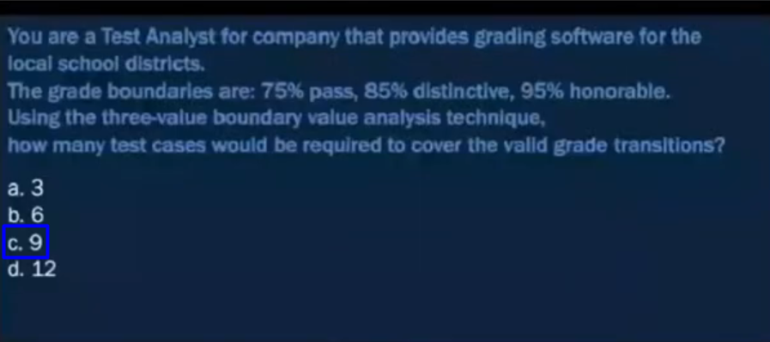

Q3

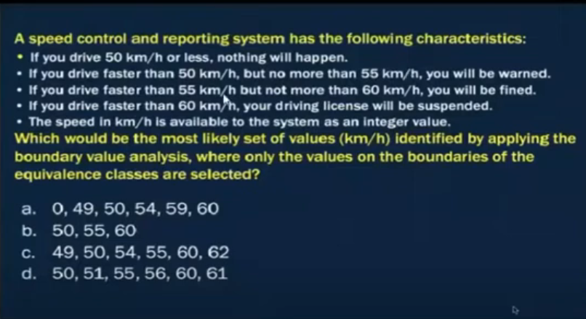

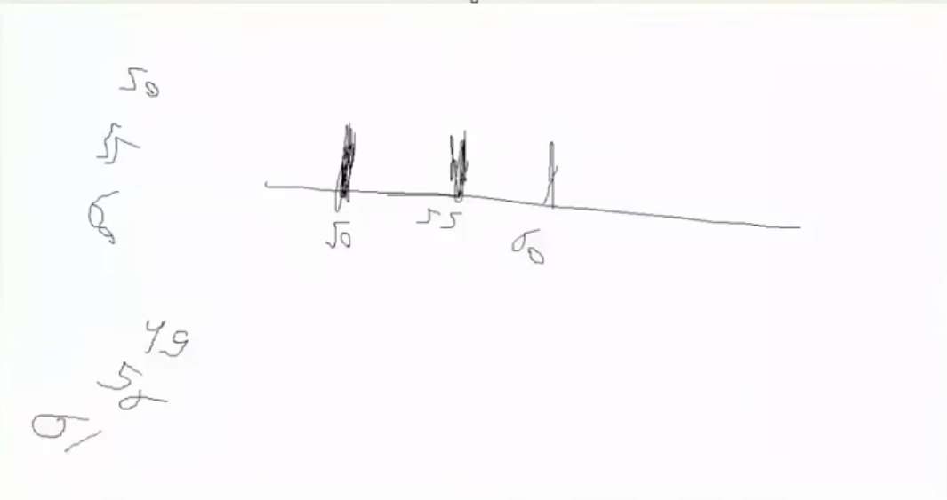

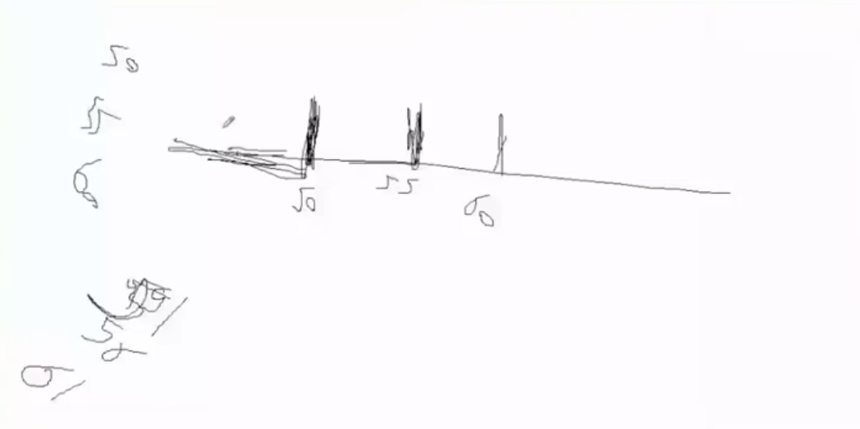

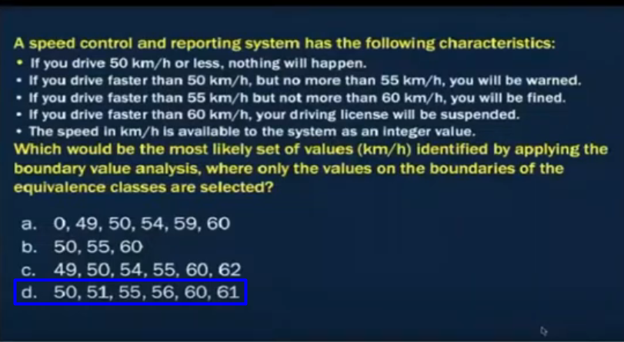

## 4.2.3-State Transition Testing

### Details part 1

4-2-Chapter 4 part 2 state _ Decision - start at 0:25

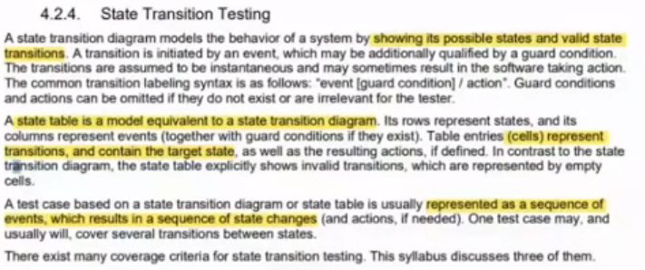

### Slide

4-2-Chapter 4 part 2 state _ Decision - start at 1:53

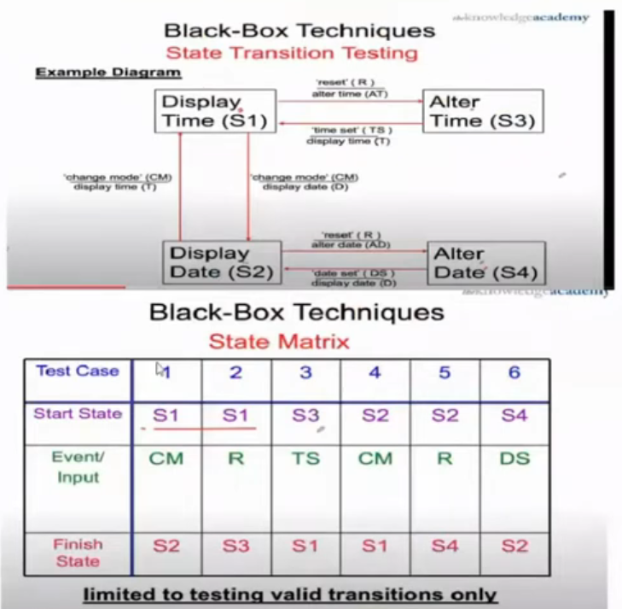

### Questions

4-2-Chapter 4 part 2 state _ Decision - start at 10:39

Q1

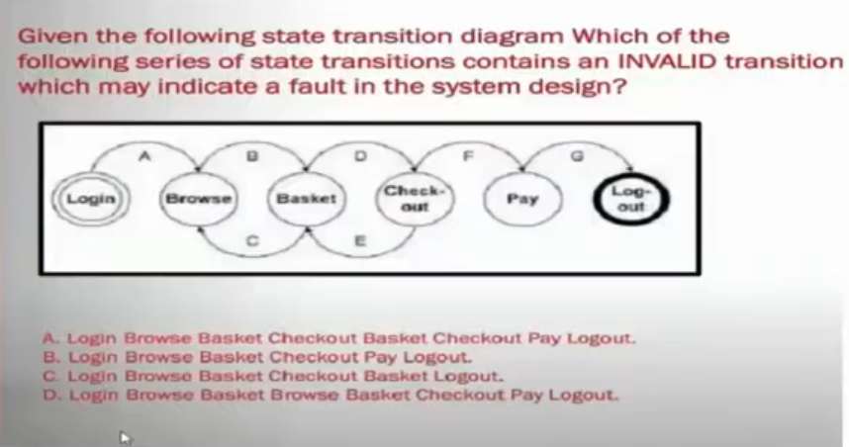

Q1 - Answer

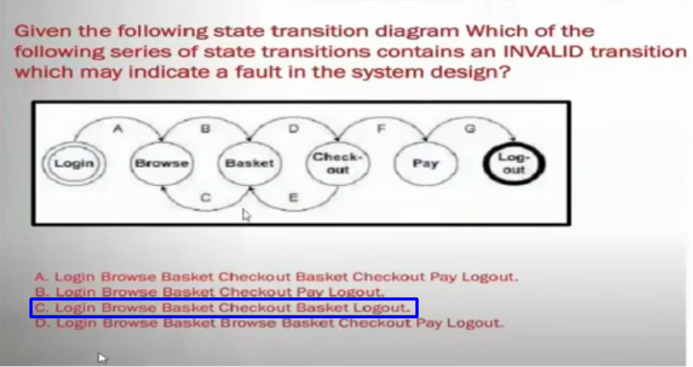

Q2

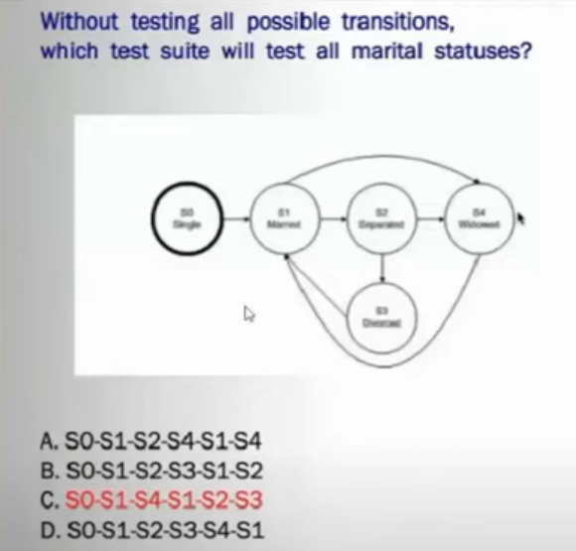

Q2 - Answer

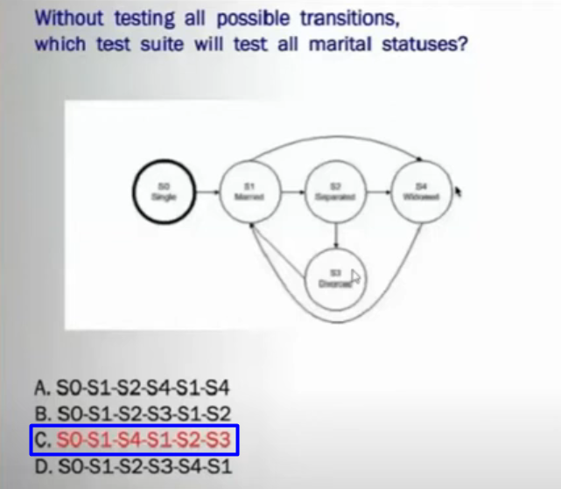

Q3

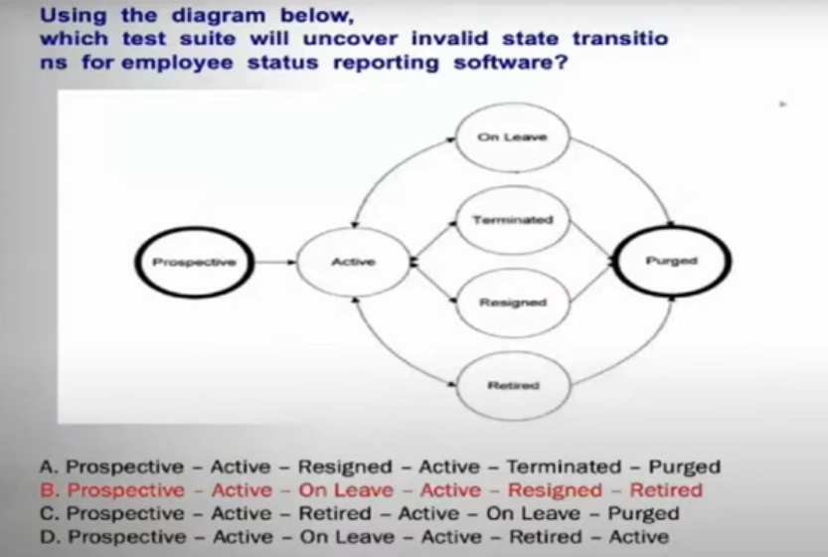

Q3 - Answer

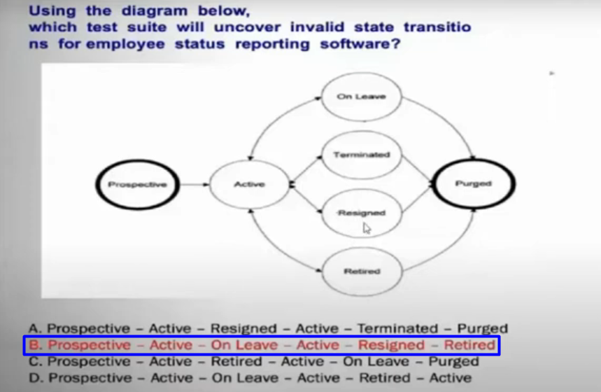

Q4

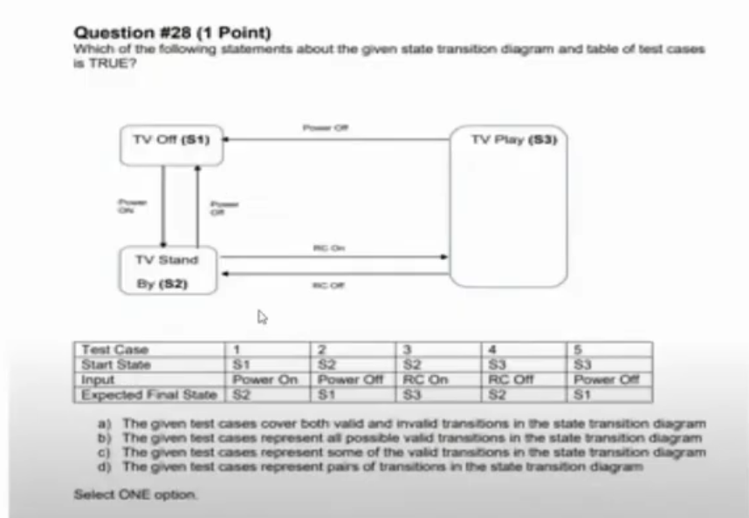

Q4 - Answer

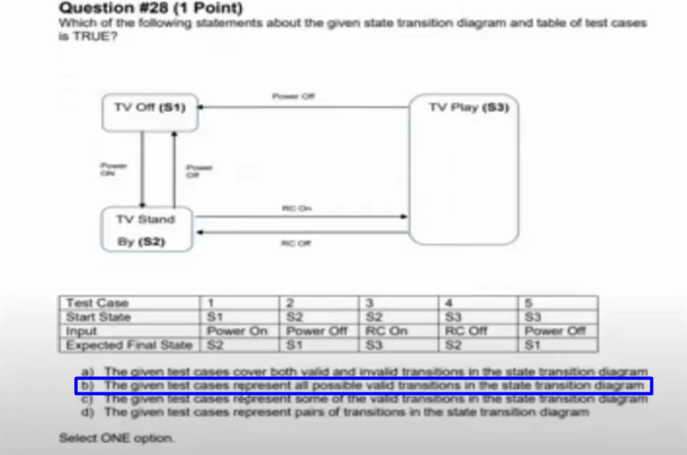

Q5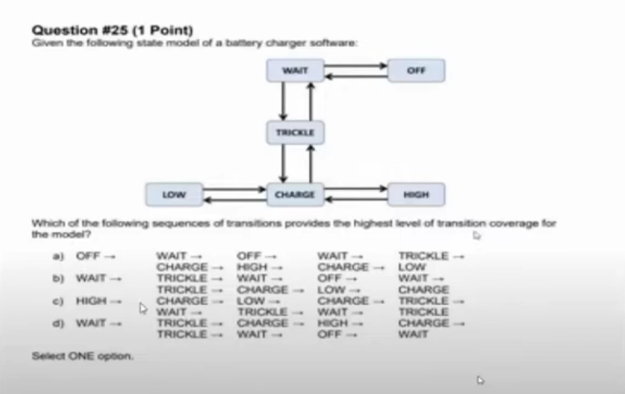

Q6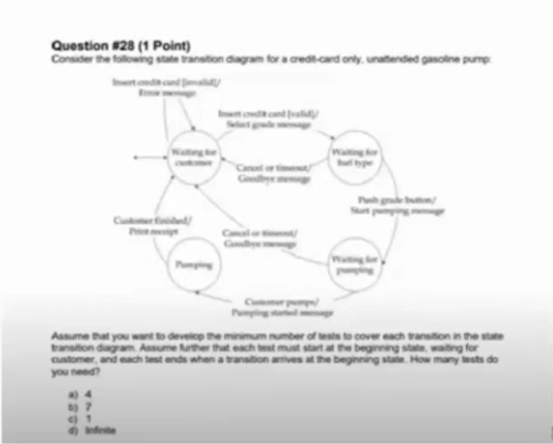

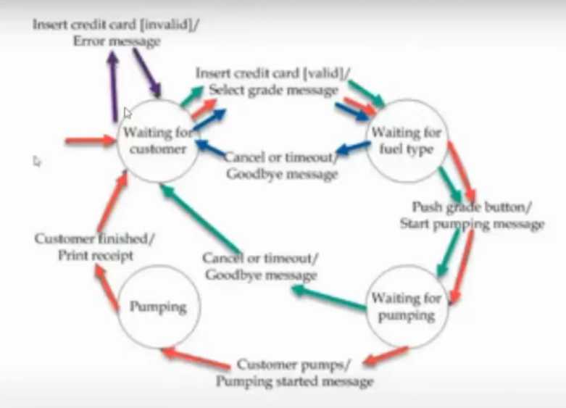

### Details part 2

4-2-Chapter 4 part 2 state _ Decision - start at 36:14

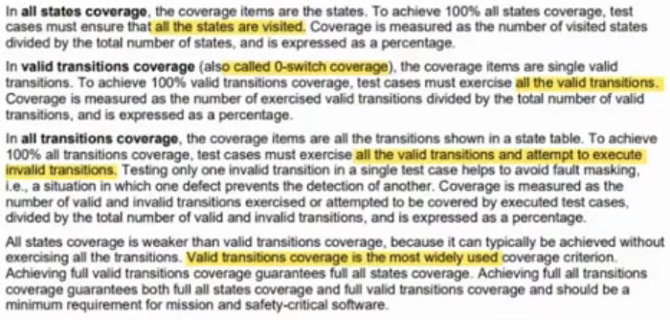

## 4.2.4-Decision Table Testing

### Slide

4-2-Chapter 4 part 2 state _ Decision - start at 46:59

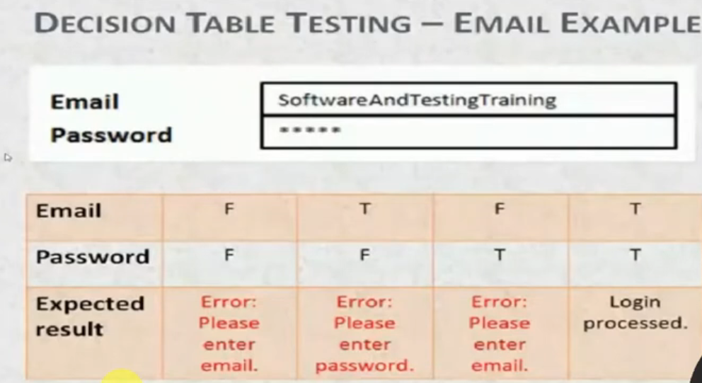

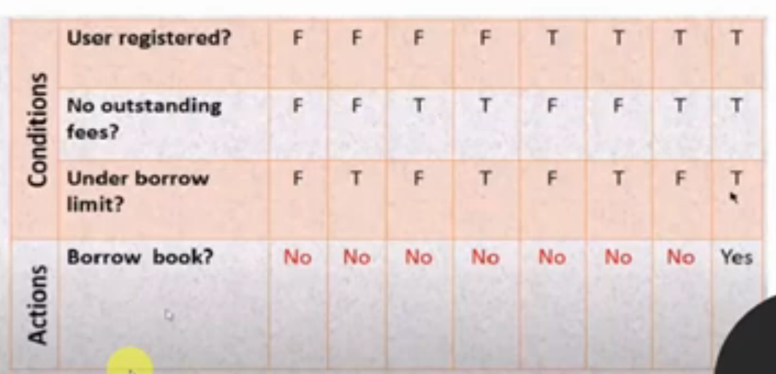

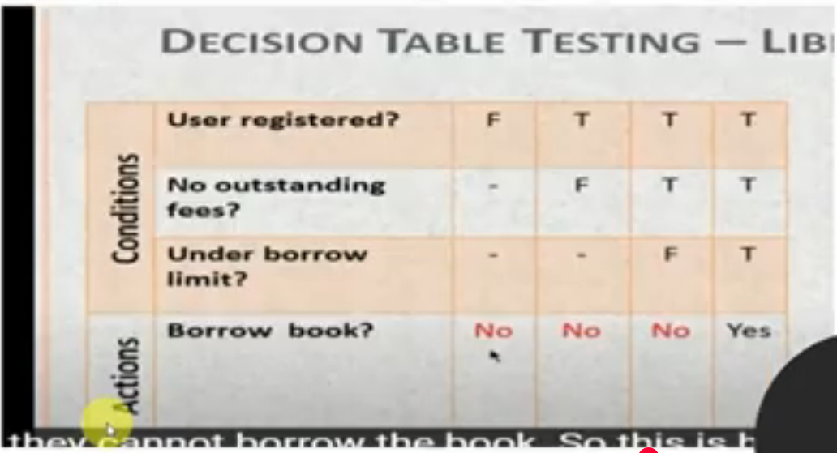

### Questions

4-2-Chapter 4 part 2 state _ Decision - start at 58:09

Q1

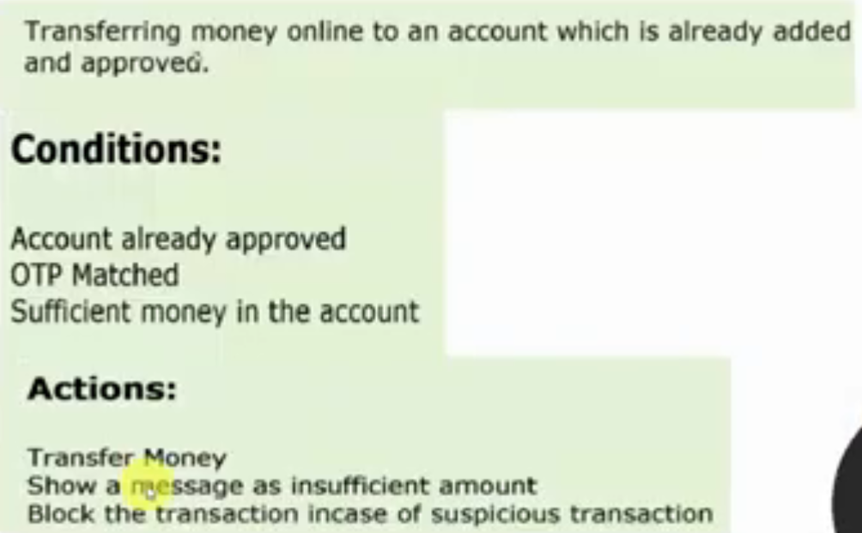

Q1 - Answer

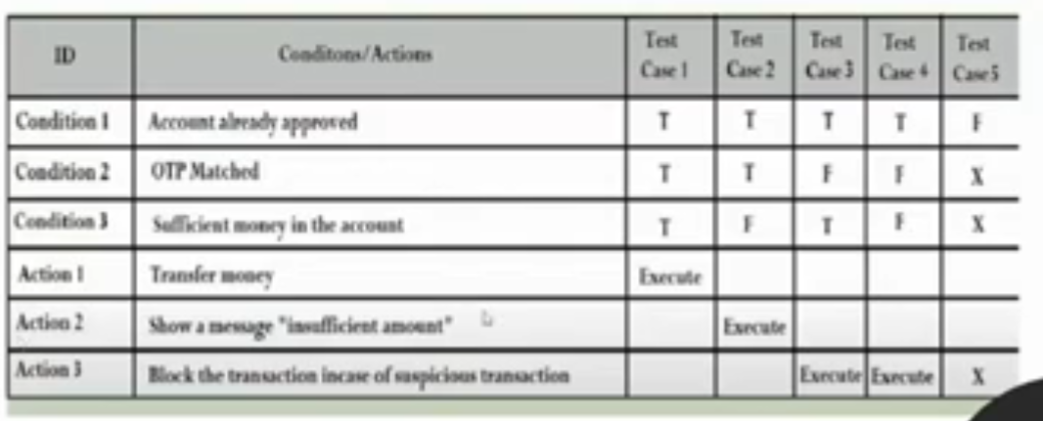

Q2

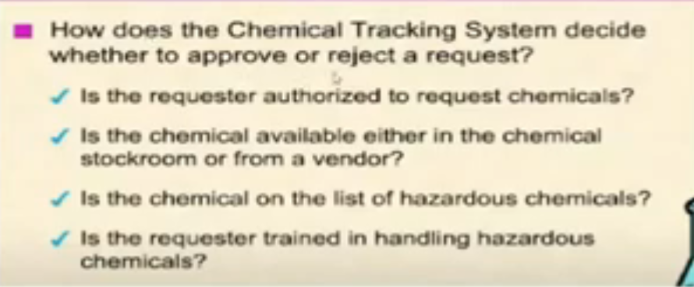

Q2 - Answer

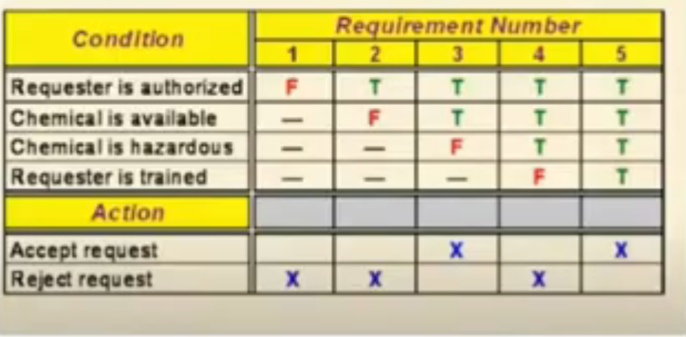

Q3

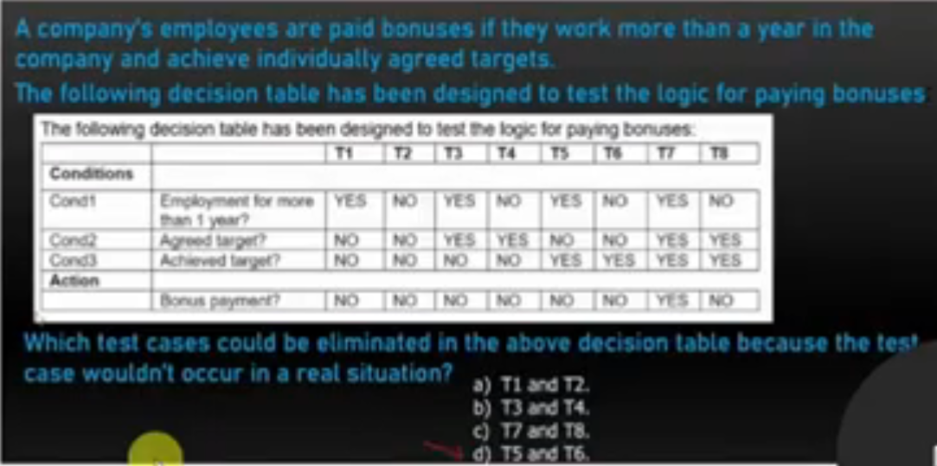

Q3 - Answer

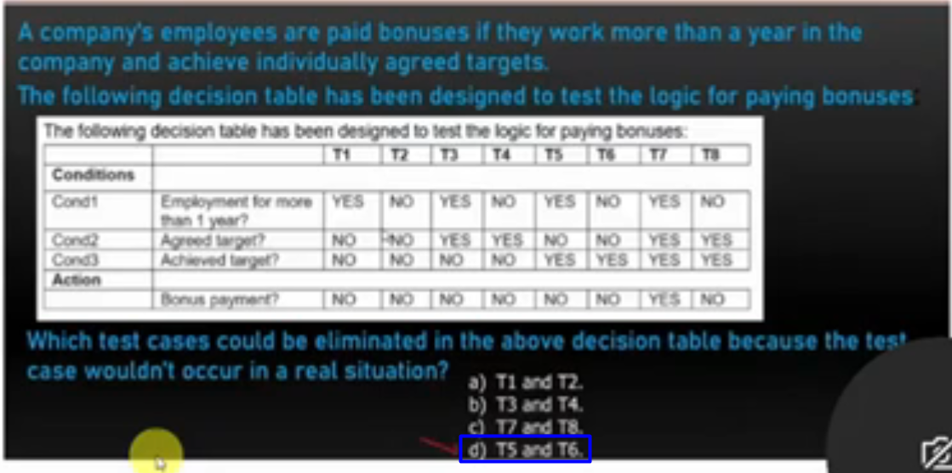

### Details

4-2-Chapter 4 part 2 state _ Decision - start at 1:10:49

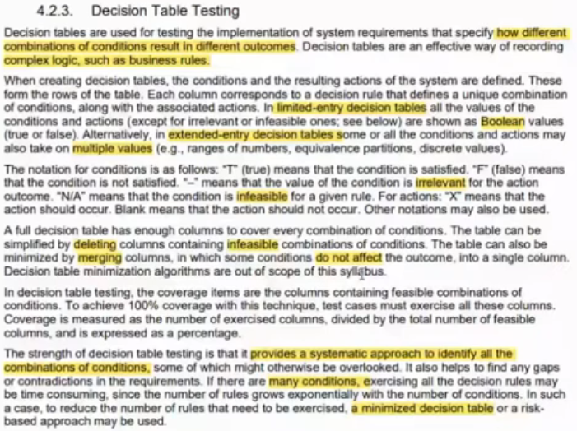

# 4.3.White box testing

## Slide

4-3-Chapter 4 part 3 (white box) - start at 17:27

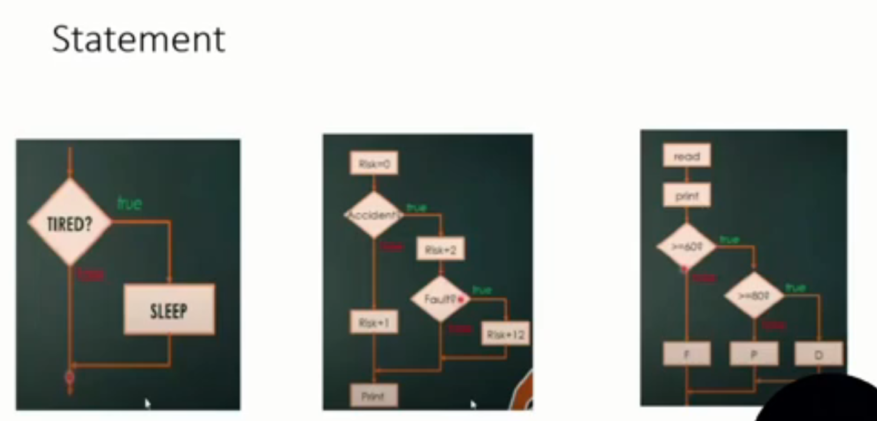

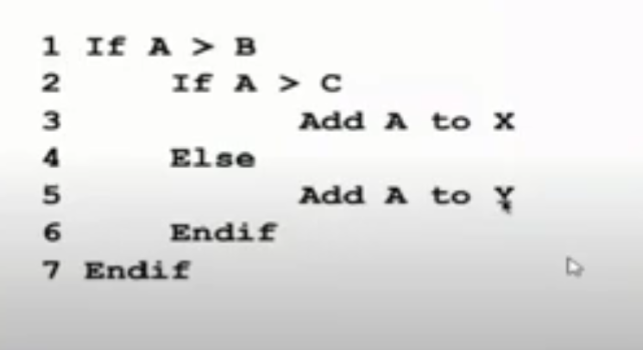

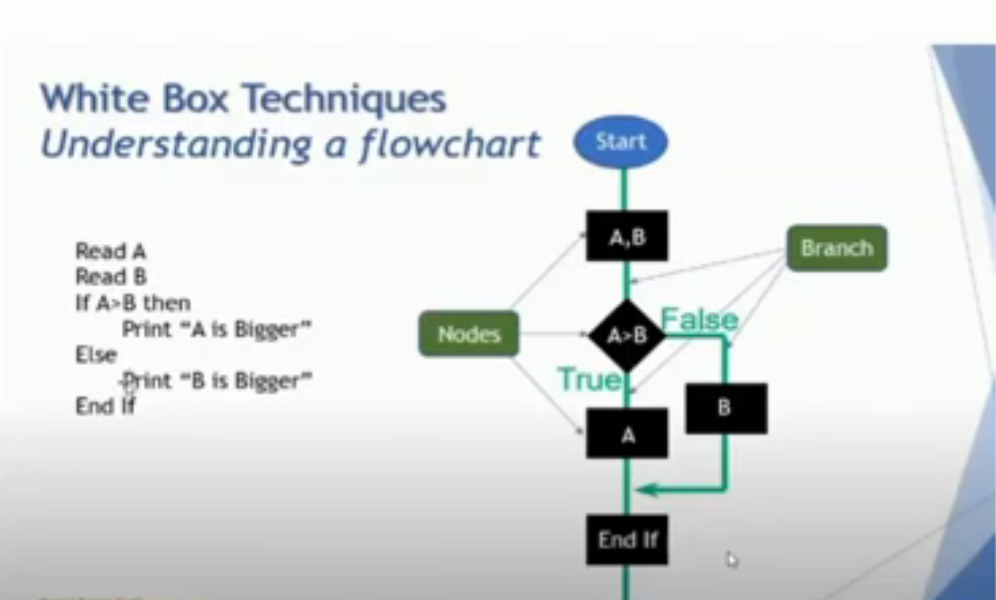

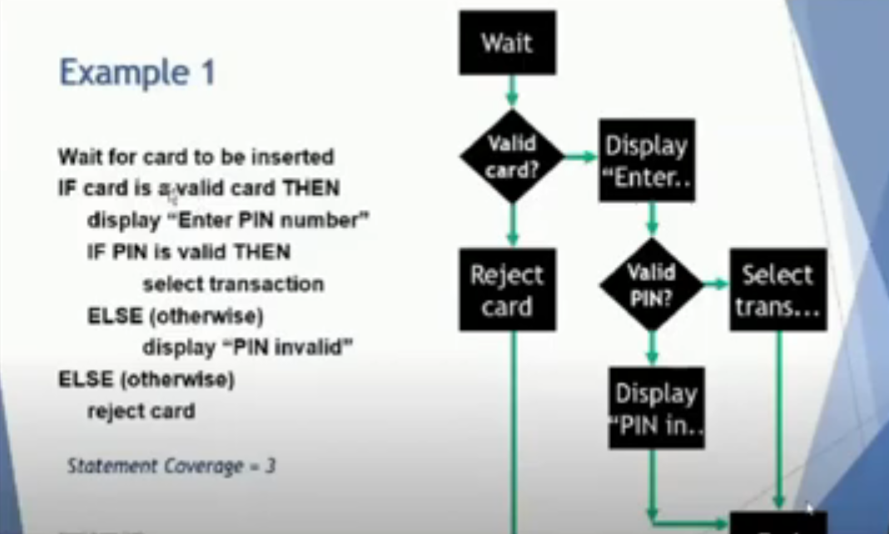

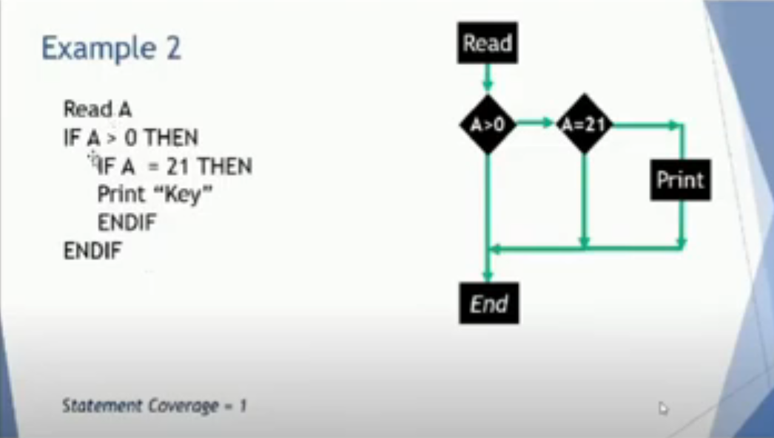

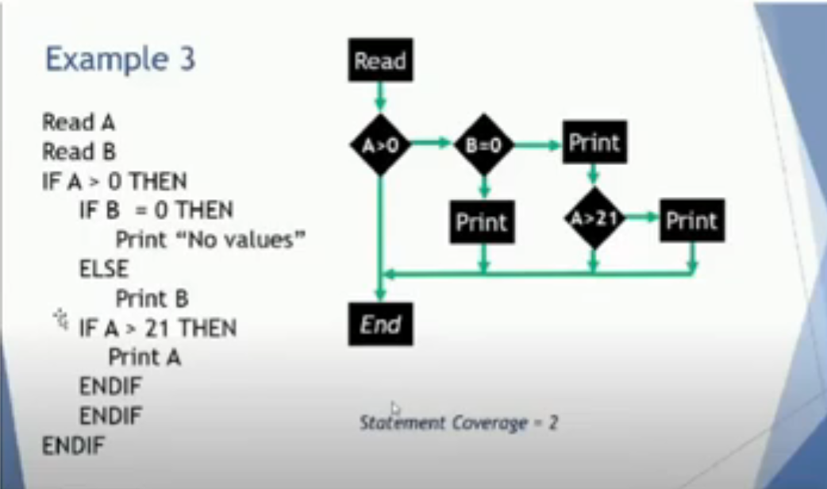

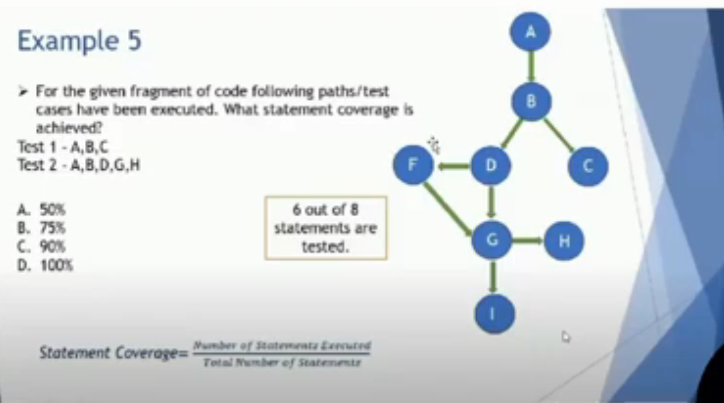

## Questions

4-3-Chapter 4 part 3 (white box) - start at 57:30

Q1

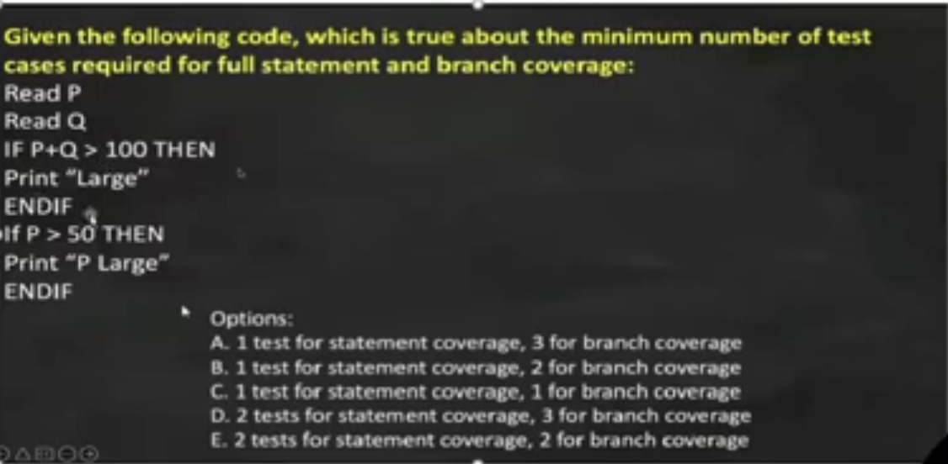

Q1 - Answer

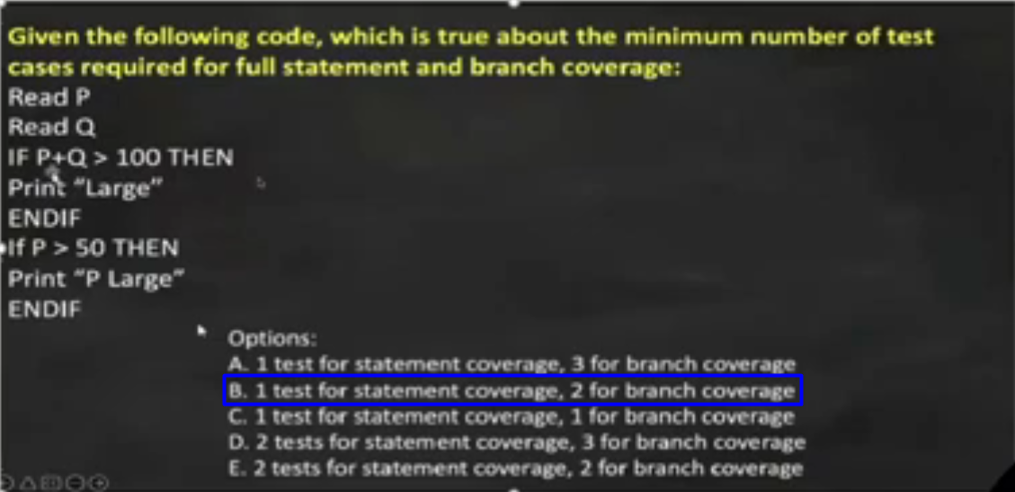

Q2

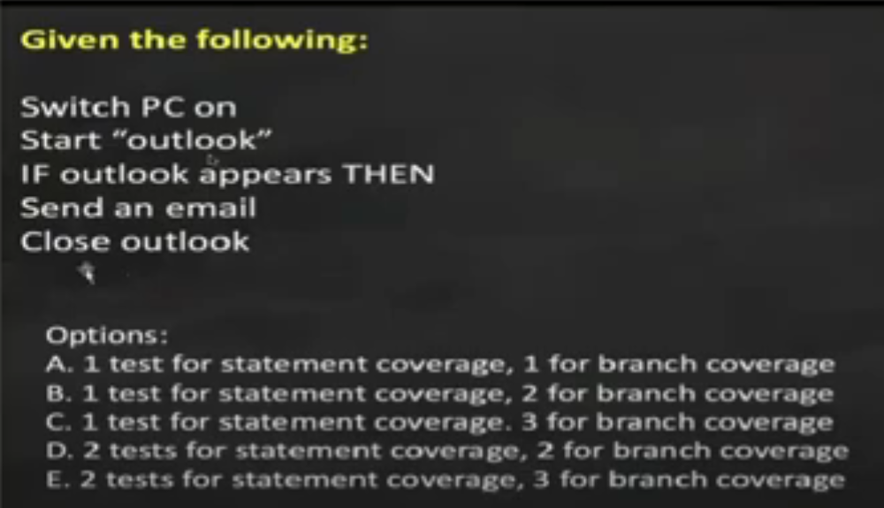

Q2 - Answer

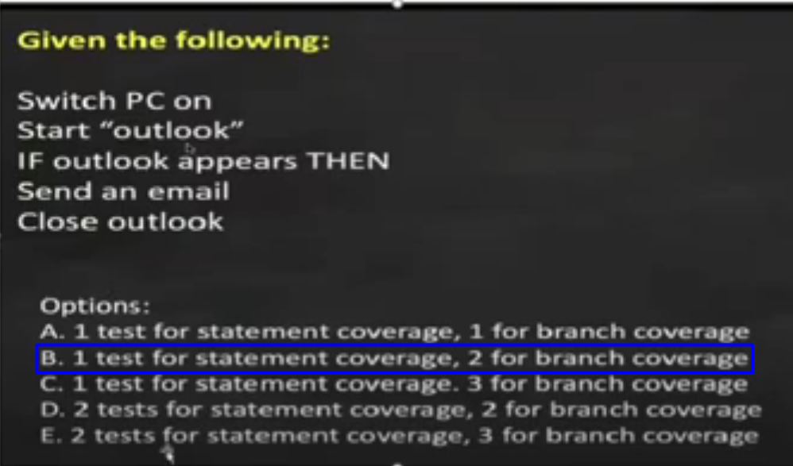

Q3

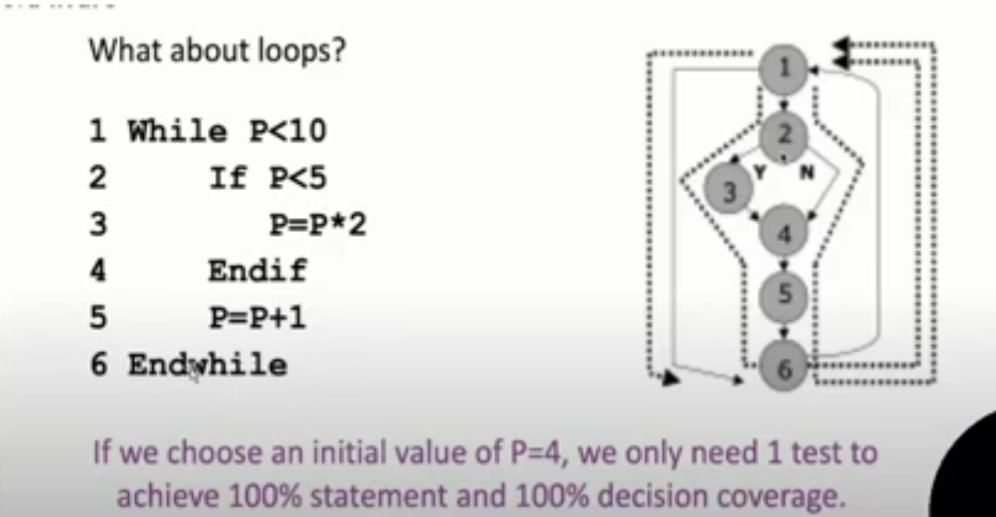

Q4

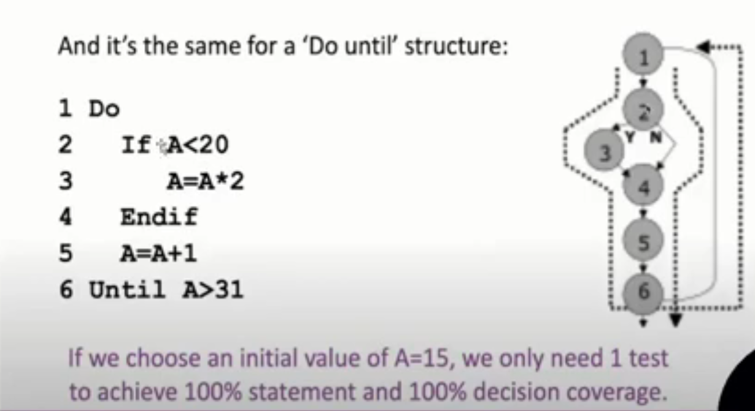

## Details

4-3-Chapter 4 part 3 (white box) - start at 1:05:53

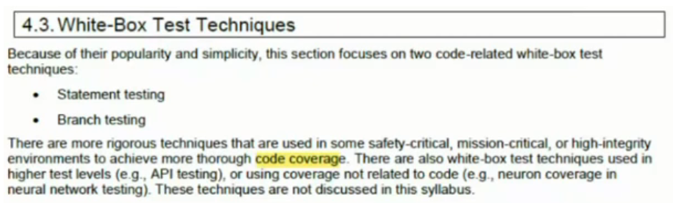

### 4.3.1-Statement Testing and Statement Coverage

4-3-Chapter 4 part 3 (white box) - start at 1:06:14

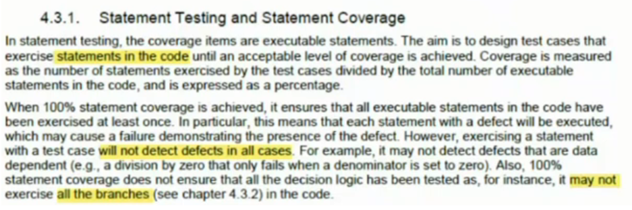

### 4.3.2-Branch Testing and Branch Coverage

4-3-Chapter 4 part 3 (white box) - start at 1:06:37

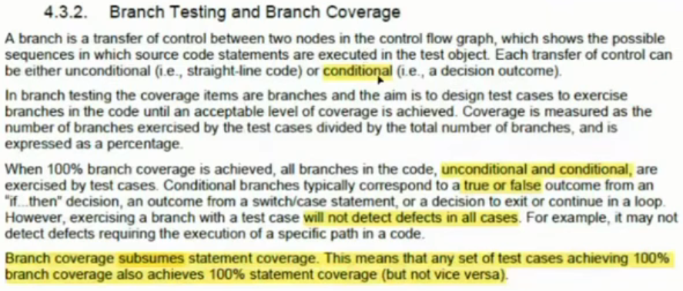

### 4.3.3-The Value of White-box Testing

4-3-Chapter 4 part 3 (white box) - start at 1:08:18

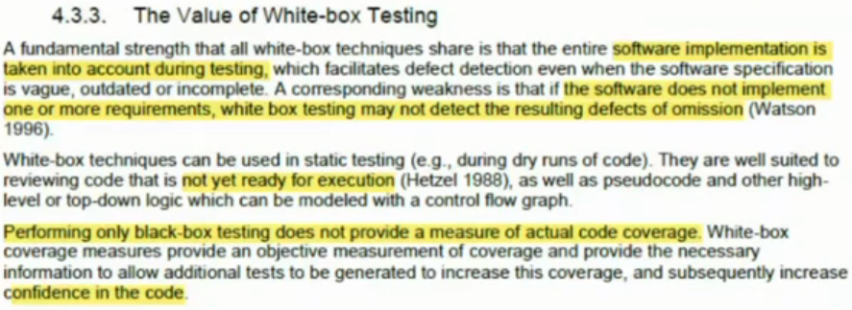

# 4.4-Experience-based Test Techniques uses

4-3-Chapter 4 part 3 (white box) - start at 1:09:48

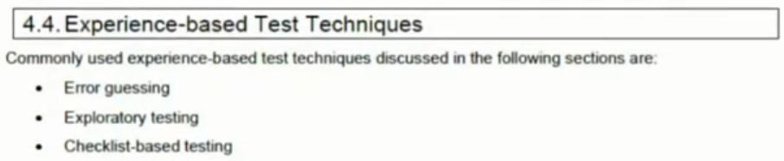

## 4.4.1-Error Guessing

4-3-Chapter 4 part 3 (white box) - start at 1:10:58

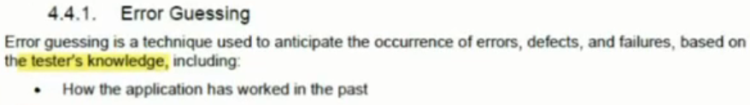

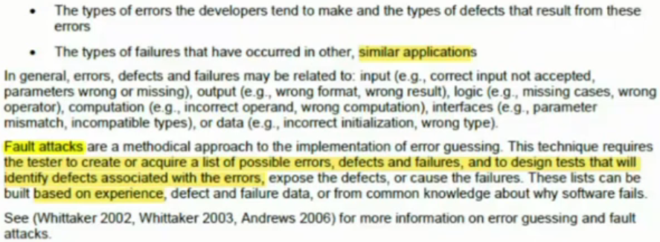

## 4.4.2-Exploratory Testing

4-3-Chapter 4 part 3 (white box) - start at 1:14:55

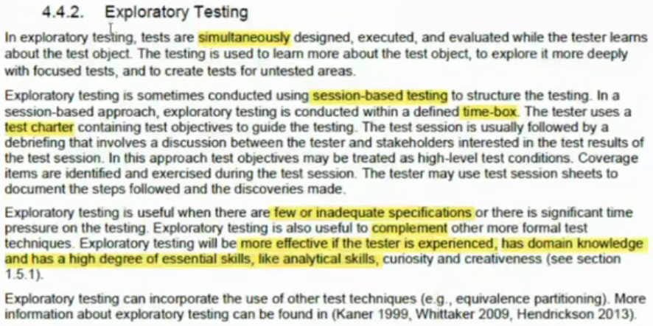

## 4.4.3-Checklist-Based Testing

4-3-Chapter 4 part 3 (white box) - start at 1:18:43

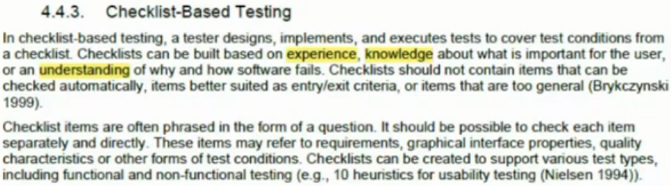

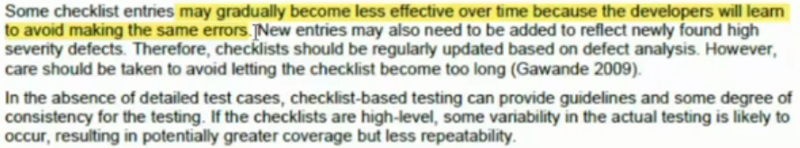

# 4.5-Collaboration-based Test Approaches

4-3-Chapter 4 part 3 (white box) - start at 1:20:39

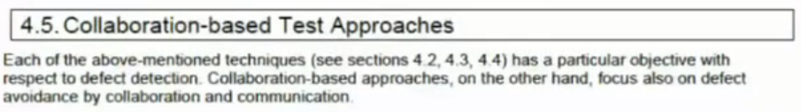

## 4.5.1-Collaborative user Story Writing

4-3-Chapter 4 part 3 (white box) - start at 1:20:39

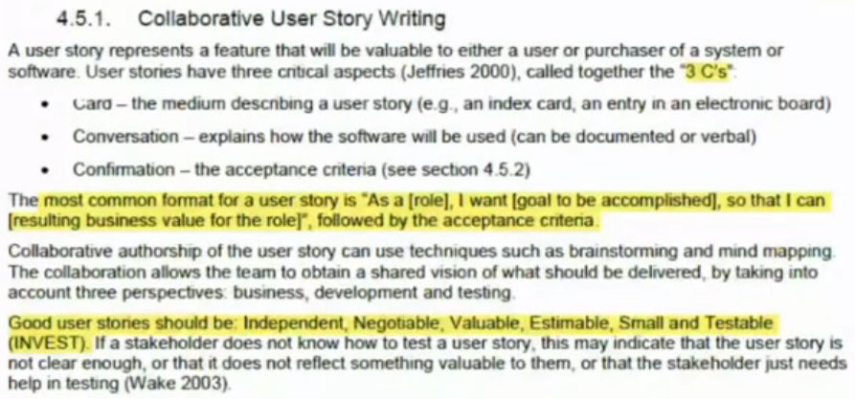

## 4.5.2-Acceptance Criteria

4-3-Chapter 4 part 3 (white box) - start at 1:25:40

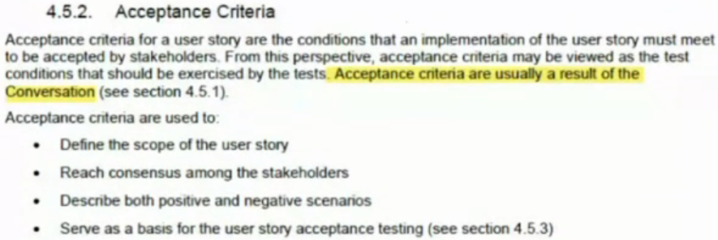

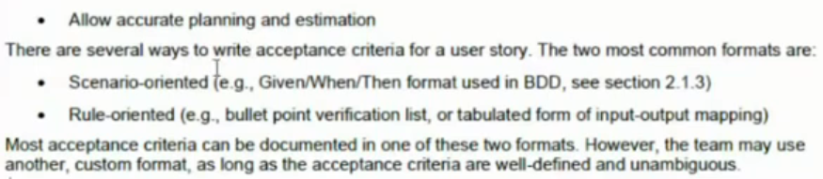

## 4.5.3-Acceptance Test-driven Development (ATDD)

4-3-Chapter 4 part 3 (white box) - start at 1:29:33

